TMAC - History and process to achieve space in Toronto
- 1994 TMAC’s precursor, the Cultural Arts Centre Toronto (CACTI), commissions feasibility study (PDF). 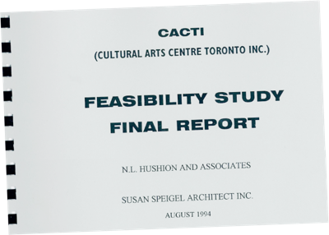

- 2003 TMAC formed to secure permanent affordable space for media arts non-profits

- 2005 TMAC commissions needs assessment for shared facility
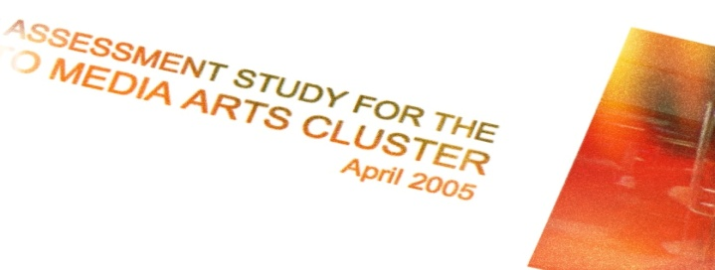

- 2011 TMAC and Urbancorp sign a letter of intent

- 2012-2015 TMAC designs the facility, investing close to $1m in public funds and thousands of volunteer hours into overseeing the build

- 2012 Urbancorp and the City enter into Section 37 agreement (PDF) subject to a land use agreement (PDF)

- 2014 Urbancorp, TMAC and the City finalize Agreement of Purchase and Sale (PDF)

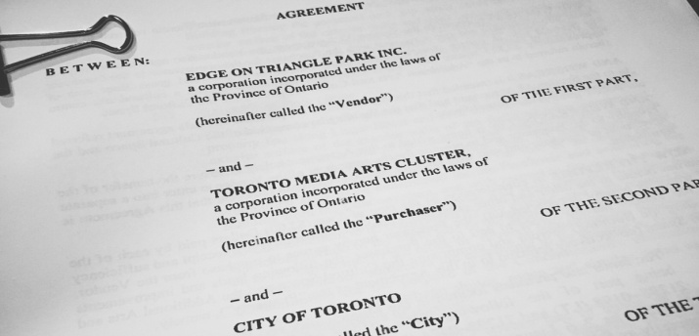

- April 2015 City directs Urbancorp not to complete sale, despite facility being substantially completed for occupancy and subsequently registered

- May 3, 2015 TMAC tenders closing deliveries; Urbancorp refuses to complete the transaction

- May 28, 2015 TMAC files a statement of claim against Urbancorp and the City of Toronto for specific performance of the APS, requiring Urbancorp to complete the sale

- June 2015 City holds a public consultation, signalling its intent to move forward with an RFP process, despite a legal action by TMAC asserting its rights to the space

- October 2015 - December 2017 Mediation begins, and all parties engage in a negotiation process

- April 2016 Urbancorp files for restructuring under bankruptcy act

- November 2017 The City blocks our proposal for temporary occupancy of the space to provide relief to our member organizations with expiring leases – despite granting Urbancorp permission to use it as an office. More info

- December 2017 TMAC files motion for an injunction for temporary occupancy of the space while we continue negotiating the settlement. Court date set for Jan. 17, 2018. More info

- February 2018 TMAC and the City of Toronto sign a settlement agreement intended to resolve the legal dispute over the TMAC space at 36 Lisgar.

- May 2018 The City of Toronto proposes (and TMAC accepts) a 6-month extension to the deadline in the MoS, as the City does not control the timeline for the conveyance of title.

- November 2018 Consent to sever the "Additional Arts & Culture Space" from TMAC is granted by the committee of adjustment and no appeal is filed by the deadline.

- March 2019 TMAC secures sponsorships totalling $2.285 million, fulfilling its obligations under the terms of the Minutes of Settlement.
We also celebrated the 1-year anniversary of moving in to our space, and launched our second year of artistic and community programming.

